Melody Lane
CSIS110
Professor Andres
1.)
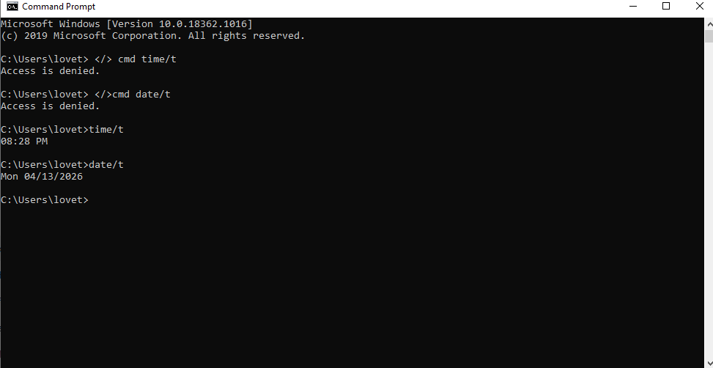
- The t/ switch displays the current time and date stamp.
- I determined the function of the t/ switch by watching a video on what each command mean.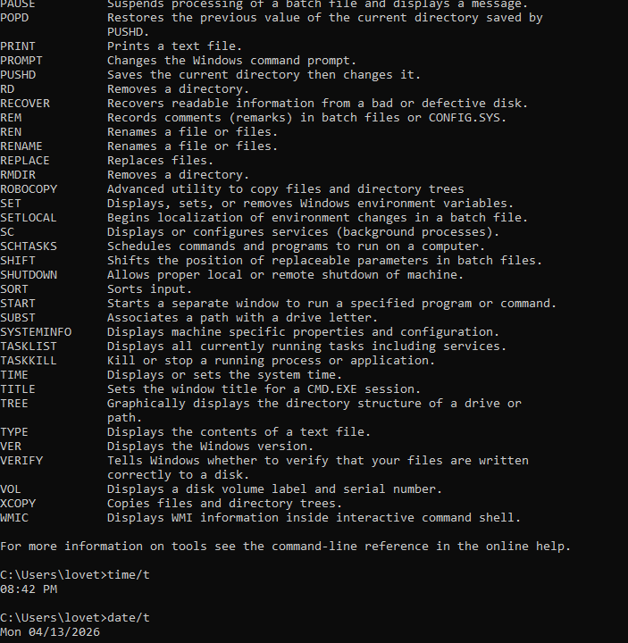
- The COLOR command set the default for the background and foreground color.
- The DIR command displays the list of files in the directory.
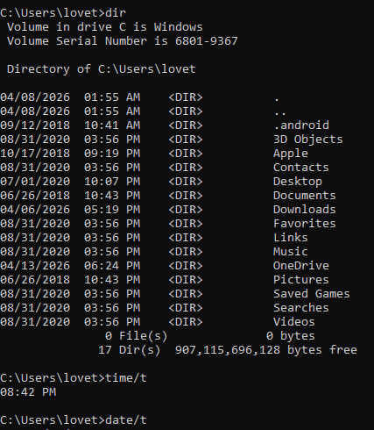
- The w/ function displays the list in a wide format.
- The dir/Q displays more details in the folder compared to dir.

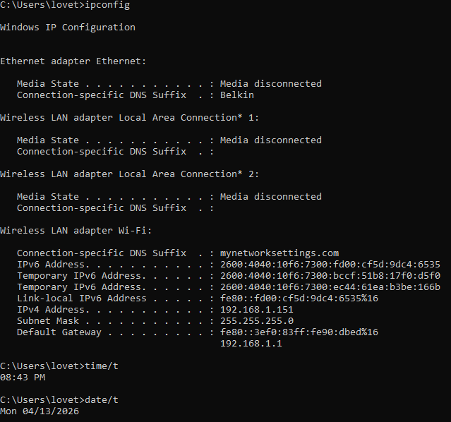
- My IP address is IPv6
- 192.168.1.1

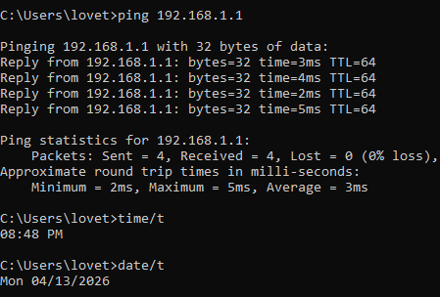
- Default Gateway - Max: 5ms Min: 2ms Avg: 3ms
Google- Max:13ms Min:10ms Avg: 12ms

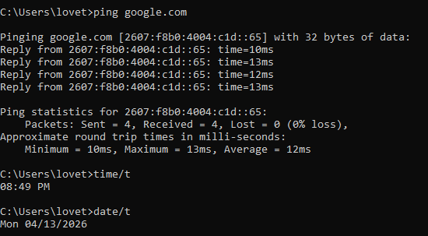
- The default gateway signals is faster because it is a local network and google signal is farther away which means it will take longer.

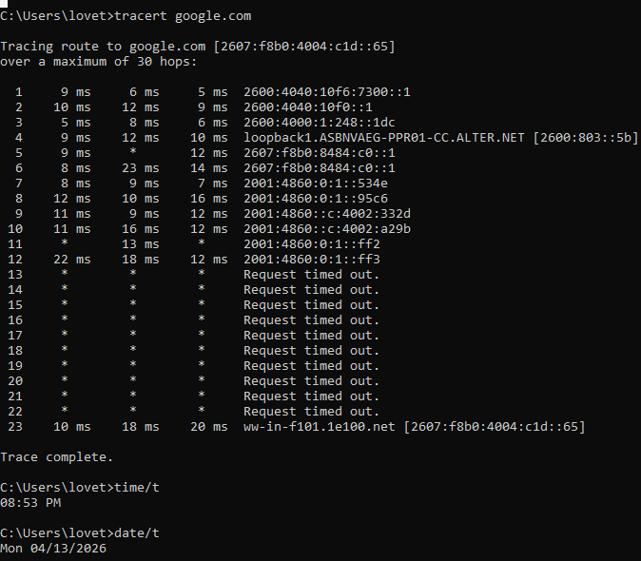
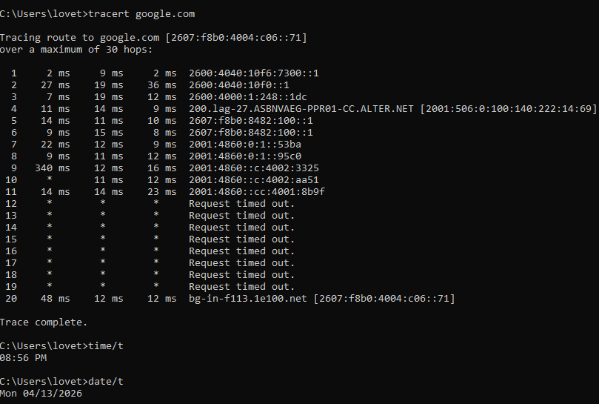
- No, the traceroute didn’t follow the same route in both traces.
- I think the differences in the traceroute were due to congestion which led to different paths.
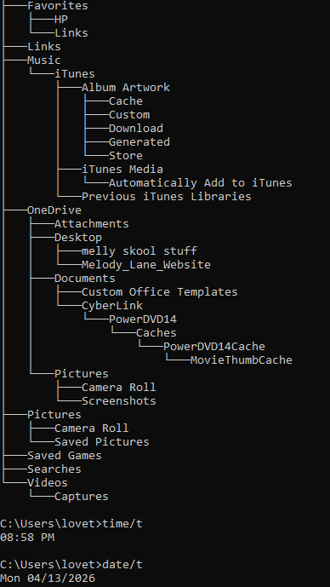
- I noticed the tree structure is long and is in a hierarchy style.
- I appreciate GUI, it’s easier to navigate, it has basic coding and beginner friendly. It was my first time using it, but I remember on my old computer the interface would pop up when starting up.

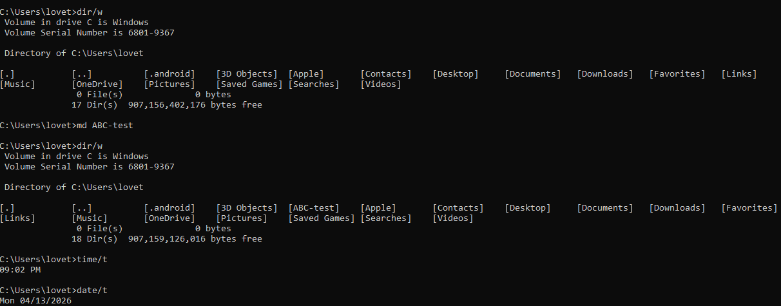

- Yes, I saw the new directory on the second DIR/
- I saw the new directory because the MD Abc-test command created a new directory. The second DIR/w displayed it.
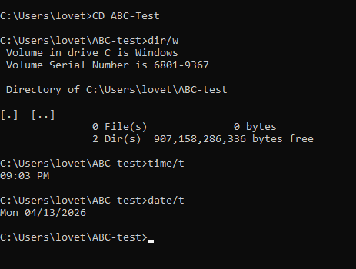
- I have 0 files in the new drive.
- The prompt shows that I am now in the directory compared to when I started at the beginning. C:users/lovet/abc-test is now showing since I added the command.
- I learned basic Commands and prompts and what their functions are. I also learned about trace routes and what a default gateway is. I enjoyed this assignment it gave me some beginner skills on what to look for in directories and overall how to navigate my computer.

I

